Algorithms for a Multi-Strategy Swing Trade Alert System

Data and Multi-Timeframe Approach
Building a robust swing trading system starts with rich data across multiple timeframes. In this scenario, we maintain intraday (1-minute, 5-minute) data, daily and weekly price data, plus index (Nifty) and volatility (VIX) metrics, and even options data. Multi-timeframe analysis is crucial because shorter intervals contain more noise[1]. For example, a stock might show an oversold signal on a 1-minute chart that is meaningless unless the higher-timeframe trend supports a rebound. Thus, our algorithms should incorporate:
- Higher Timeframe Trend Context: Use daily/weekly charts to determine the primary trend and key support/resistance levels. Lower timeframes (like 5-min or 15-min) can confirm that the short-term movement aligns with the larger trend, reducing false signals[1].
- Lower Timeframe Entry Timing: Use 1-minute or 5-minute charts for precise entries once the broader conditions are met. For instance, one could wait for a 5-minute oscillator (like RSI) to reach oversold and then drill down to the 1-minute chart for an exact entry trigger. This multi-timeframe confirmation helps filter out noise and improves signal reliability[2].
By combining signals across timeframes, the system ensures that alerts are high-confidence – a stock is not only fundamentally or trend-wise favorable on daily charts but also giving a timely entry signal intraday.

Trend and Relative Strength Filters
To avoid being a “one-trick pony,” the system should first filter candidates using trend-following algorithms and relative strength analysis:
- Moving Averages for Trend: Moving averages are foundational trend indicators. For example, a longer-term moving average (like a 50-day SMA) sloping upward indicates an uptrend. A classic signal is a moving average crossover: when a shorter-term EMA crosses above a longer-term SMA, it often coincides with trend reversals to the upside[3]. This can serve as a preliminary screen to find stocks transitioning into uptrends (or already trending up).
- ADX or Trend Strength Measures: The Average Directional Index or even simpler methods (like examining the slope/separation of moving averages or using Parabolic SAR dots) can measure how strong a trend is. For instance, the Parabolic SAR shows dots below price in an uptrend and above price in a downtrend; when its dots flip and accelerate in one direction, it signals a strong trend[4]. We can use such indicators to ensure we focus on stocks with a definable trend (preferably upward for long swing trades).
- Relative Strength vs Index/Sector: Our system monitors Nifty and sector indices, so an algorithm should rank or filter stocks by their relative performance. A stock that has been outperforming the Nifty or its sector peers (e.g. higher % gain over the last weeks) demonstrates relative strength. Such leaders often continue to outperform. This comparative algorithm might maintain a relative strength score for each Nifty100 stock, highlighting those showing resilience or strength even if the market dips.
By applying these trend and relative strength filters at a first stage, we generate a watchlist of strong-candidate stocks (those in solid uptrends or emerging from basing patterns, with strength against the market). This addresses the “list then filtered list” part of a multi-level alert system – we’re not examining all stocks, just the most promising ones.
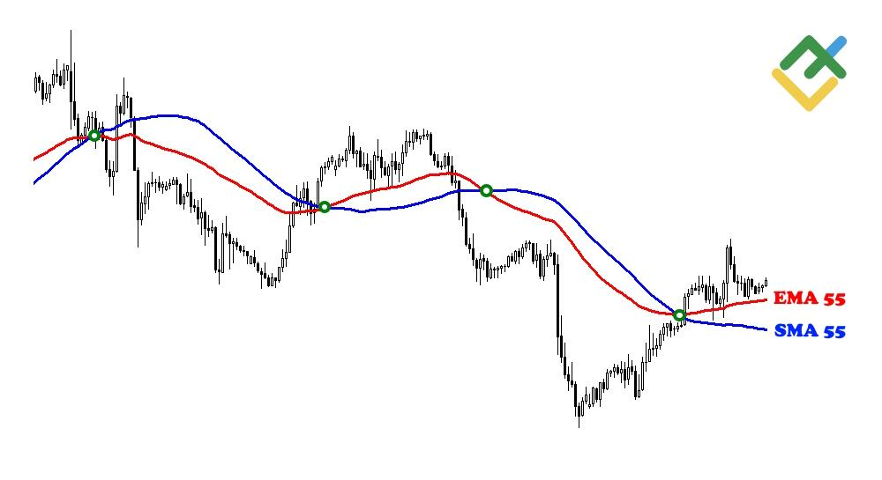
Moving average crossover example: the red EMA crosses above the blue SMA, indicating a bullish trend reversal signal[3]. Such trend indicators help filter stocks in uptrends.

Momentum and Oscillator Signals (Overbought/Oversold)
Once we have a list of trending, strong stocks, the next algorithms identify entry and exit points using momentum oscillators. These tools help find moments when a stock is temporarily oversold in an uptrend (ideal swing buy) or overbought (profit-taking points):
- Relative Strength Index (RSI): RSI is one of the most popular swing trading indicators, known for its high practical forecasting accuracy in identifying momentum extremes[5]. The RSI measures the ratio of recent gains to losses and oscillates between 0 and 100. We use it to spot oversold conditions (e.g. RSI < 30) as potential buy zones and overbought conditions (RSI > 70) as potential exit or sell-short zones[6]. An intraday entry algorithm might trigger when RSI on a 5-minute chart climbs back above 20 or 30 after being oversold, signaling a probable upward reversal. RSI is favored because it not only indicates overbought/oversold, but its relatively responsive formula (weighted to recent price changes) often makes it timely in generating signals[5].
- Stochastics Oscillator: Similar to RSI, stochastic %K/%D can be used to find oversold conditions in an uptrend (e.g. stochastic < 20) and signal a bounce when the %K line crosses above %D in oversold territory. This can corroborate RSI signals. Stochastic is fast-moving and sensitive, so it provides early warnings of momentum shifts, albeit with more noise (hence best used in combination).
- MACD (Moving Average Convergence Divergence): MACD is a momentum/trend indicator that uses two EMAs (fast and slow) and their difference (the MACD line and histogram). An algorithm can use MACD crossovers (MACD line crossing above signal line) to identify upswings in momentum. More powerfully, the system should detect bullish divergences: e.g., price makes a lower low but MACD forms a higher low, hinting that downward momentum is waning[7]. Such divergences are strong predictors of reversals and can be high-confidence alerts when aligned with oversold RSI or a known support level.
- Divergence Scans (RSI/MACD): A specific algorithm can scan for positive divergences between price and oscillators. For instance, if a stock’s intraday low is lower than the previous day’s low, but RSI is higher this time (not as oversold as before), it suggests selling pressure is weakening – a potential swing low. These conditions often precede a bounce.
Momentum indicators like RSI and MACD help the system pinpoint “exact buy zones” by identifying when a strong stock has pulled back too far too fast and is likely to mean-revert upward[8]. Combining an oscillator with the trend filter is essential: an oversold reading is most useful when the larger trend is bullish, as it likely indicates a pullback rather than a breakdown. This multi-indicator approach mirrors how successful traders use 2-4 complementary indicators for confirmation rather than a single signal[9].
RSI oscillator example: when RSI falls below the oversold threshold (e.g. 30) it signals a potential buy, and above 70 an overbought condition to sell[6]. Using RSI on multiple timeframes can refine entry timing in a swing trade.

Volatility and Mean-Reversion Algorithms
Volatility indicators and mean-reversion logic can alert us to extremes in price movement, which often make for good swing entries/exits:
- Bollinger Bands: Bollinger Bands plot an SMA (typically 20-period) with upper and lower bands at a certain standard deviation of price. They effectively show volatility: when bands widen, volatility is high; when they narrow, volatility is low[10]. Our system can exploit two Bollinger-based signals:
- Mean Reversion Signal: If price pierces outside the Bollinger Band, it indicates an extreme move. A simple strategy: Buy when two consecutive candles close below the lower band (anticipating a bounce back toward the mean), and sell/exit when price reaches the middle band (SMA)[11]. Likewise, if two candles close above the upper band, it may signal an overbought condition to sell or even short. This algorithm capitalizes on short-term over-extensions.
- Volatility Breakout Filter: Conversely, a period of band narrowing (low volatility squeeze) often precedes a sharp move. An alert can trigger when bands start expanding after a squeeze, combined with price breaking out of a recent range – signaling the start of a swing move. This helps catch momentum breakouts early (with the caution to trade in the direction of the prevailing trend to improve odds).
- Average True Range (ATR) and Range Filters: ATR measures average volatility range. We can use ATR-based stop or ATR channels to gauge if a move is statistically significant. For instance, if intraday price moves more than 2× ATR in one direction, it might be overstretched and due for a snap-back. The system could flag such cases as potential mean-reversion opportunities or, if trend-aligned, as momentum breakouts requiring volume confirmation.
- VIX and Volatility Regime: Incorporating the Volatility Index (VIX) helps adapt the strategy to market conditions. A high VIX (indicating high market volatility/fear) often correlates with larger swings and potential market bottoms, whereas a low VIX indicates complacency. An algorithm might reduce longs or require stronger confirmation when VIX is above a threshold (since bearish moves can accelerate), and conversely watch for buy opportunities when VIX spikes extremely high, as panic selling could be near exhaustion. In essence, the system adjusts its aggressiveness of signals based on volatility regime.
Using volatility-based algorithms ensures the alert system doesn’t generate signals on every minor price wiggle. Instead, it focuses on statistically significant moves – either extreme deviations ripe for reversal or volatility contraction setups poised for a big swing.
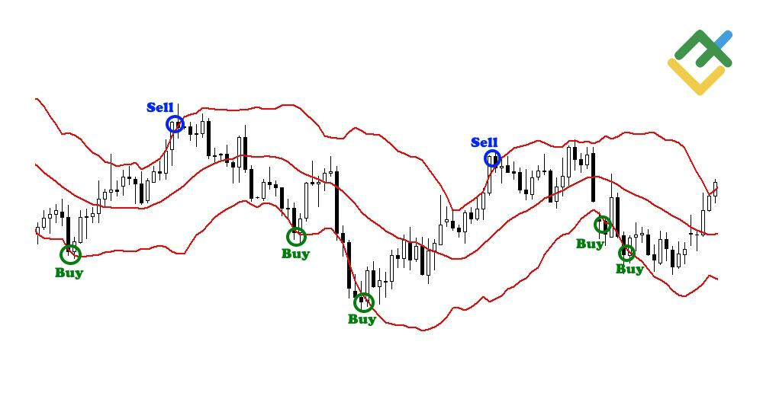
Bollinger Bands example: price closing below the lower band (circled) can signal an oversold bounce, while band width indicates volatility[10][11]. Such volatility-based signals add another layer to our multi-algorithm system.

Volume and Market Sentiment Indicators
To further increase confidence and reduce noise, incorporate volume and sentiment-based algorithms. These provide confirmation that a price move or signal is backed by substantial market interest:
- Volume Spike and Trend Confirmation: Unusual volume can precede or confirm big moves. For each stock, an algorithm tracks volume relative to average. If a bullish signal (say RSI oversold bounce or a breakout) is accompanied by volume far above normal, it’s more credible. Indicators like On-Balance Volume (OBV) accumulate buying vs. selling pressure and can be used to detect divergences. For example, if price has been rising but OBV is flat or falling, it suggests lack of true accumulation and a possible false rally[12]. Our system can flag such volume-price divergences as warning signals (avoiding long entries where volume doesn’t confirm price). Conversely, a stock making new highs on rising OBV indicates genuine buying interest[12], supporting continuation trades.
- Accumulation/Distribution (A/D) and Money Flow: Similar to OBV, these indicators analyze whether money is flowing into or out of a stock. They can complement price signals. For instance, a stock might pull back mildly in price while A/D line keeps rising – indicating smart money buying the dip. An algorithm watching this could prioritize that stock, expecting a swing up once the dip ends.
- Market Breadth & Sector Strength: Our system monitors the Nifty index and sectors. A breadth algorithm might look at how many Nifty100 stocks are above their 50-day MA (a gauge of overall market health) or whether defensive sectors are leading (risk-off mode). If the broader market or the stock’s sector is notably weak, the system might filter out long alerts for that stock to avoid fighting the tide. Ideally, we target stocks whose sectors are also in uptrends or showing relative strength. This aligns each trade with prevailing market sentiment.
- Options Open Interest and Sentiment: If option data is available, we can incorporate an open-interest (OI) analysis. High OI at certain strike prices can indicate expected support/resistance levels (e.g. a stock consistently bounces near a strike price with huge put OI). A surge in Call OI might signify bullish sentiment by traders. Additionally, the put/call ratio extremes can be contrarian indicators – an extremely high put/call ratio on a stock could mean excessive pessimism (ripe for a bullish swing if fundamentals don’t justify that level of fear). Our alert system could use these as context signals, e.g., “bullish swing candidate XYZ has heavy put accumulation (high put/call) – any reversal signal is extra potent as shorts may cover.” These option-based alerts add a sentiment dimension beyond price/volume.
By combining price analysis with volume and sentiment, the system filters out low-quality signals (e.g., those lacking volume confirmation) and identifies situations where big players’ activity supports the trade. According to trading best practices, volume-based indicators help confirm if a price move is trustworthy[13] – we integrate that principle to boost the confidence level of our alerts.

Multi-Strategy Signal Combination
Instead of relying on one strategy, our system employs multiple strategies in parallel, each generating candidates, which are then cross-verified:
- Trend Continuation Strategy: Finds stocks in strong uptrends (per trend filters) and alerts on pullbacks. For example, a stock above its 50-day MA with an intact uptrend might alert when its intraday RSI drops below 25 and then recovers – implying a likely continuation of the uptrend after a short-term dip. This strategy buys dips in an uptrend, a high-probability approach when done with confirmation (as the broader trend is a tailwind).
- Breakout/Momentum Strategy: Scans for breakouts from consolidations or resistance. Using pattern recognition (like flags, triangles) or simply a volatility breakout as noted, it will alert when a stock exits a range on high volume. This strategy capitalizes on the start of new swings. To reduce false breakouts, it can require that OBV or volume increase with the price and that the overall market isn’t hostile (e.g., Nifty not in a downtrend).
- Mean Reversion Contrarian Strategy: Looks for extreme oversold conditions in quality stocks or sectors. For example, if a normally strong stock falls several days in a row into an oversold oscillator reading while still fundamentally sound or in a long-term uptrend, the system issues a swing buy alert expecting a bounce. This often aligns with scenarios where fear is high but likely overdone (here monitoring VIX and put/call can help identify an overly fearful market ripe for a reversal).
- Multi-factor ML/Quant Model (Optional): As an advanced layer, a machine learning model could be trained on technical features (trend, momentum, volume, option data) to output a “swing score” for each stock each day. Research shows machine learning can process vast data and technical indicators to predict price movements with some edge[14]. Such a model could serve as an overlay that ranks or filters the alerts generated by the rule-based strategies, ensuring only those with historically high win probability are shown. For instance, a trained model might recognize complex patterns or indicator combinations that precede big swings (something a single indicator can’t do alone). This adds a probabilistic, data-driven confirmation to the mix.
Critically, these algorithms don’t work in isolation. The system cross-verifies signals: a stock might first appear in the Trend Continuation list (uptrend intact), then also trigger a Mean Reversion signal (oversold intraday) – the intersection of those gets priority as a high-probability alert. This layered approach echoes the advice that combining different indicator types (trend + momentum + volume) yields more reliable results[15][16]. By having multiple algorithms feed into a common alerting module, we ensure we’re not betting on one method; it’s the confluence of evidence that triggers a strong buy/sell alert.

Multi-Level Filtering and Alerting
The question hints at a multi-level alert system: an initial list, a filtered list, and finally precise timing signals. Here’s how the algorithms come together in stages:
- Level 1 – Broad Scan (Watchlist Generation): Use trend filters and relative strength to scan the universe (Nifty 100 stocks). This might run end-of-day on daily data to flag, say, 15-20 stocks that are in uptrends or strong against the market, and maybe another 5-10 that are in basing patterns with potential to break out. This watchlist is where we’ll focus our intraday monitoring, drastically cutting noise.
- Level 2 – Refined Screening: During market hours, apply secondary criteria on the watchlist. This includes checking sector/index conditions (e.g., ensure the sector isn’t sharply underperforming at the moment), and monitoring oscillators and volatility. This stage might produce a filtered list of, for example, 5 stocks that meet conditions like “pulling back on low intraday RSI while volume remains moderate (no heavy dumping)”. Think of this as identifying which watchlist stocks are nearing a buy zone but not yet triggering.
- Level 3 – Precise Entry/Exit Alerts: The final step is the exact timing algorithm. For a stock that passed Level 2, the system waits for a concrete trigger: e.g., “Stock XYZ now has a 5-minute RSI that crossed back above 30 from oversold, MACD histogram ticks up, and a bullish engulfing candle formed at intraday support.” When such a confluence appears, the system issues a Buy Alert with the price zone and timestamp. Similarly, sell alerts can be generated when a stock’s swing moves mature (e.g., RSI hits overbought or a trailing stop is hit). By only alerting at this final confirmation stage, we avoid noise – the user isn’t bombarded with every oversold reading, only those aligned with multiple favorable factors.
Throughout this pipeline, risk management rules are implicitly embedded: for instance, if a stock triggers an alert but immediately the market sentiment turns (say Nifty plunges or VIX spikes unexpectedly), the system can either withhold the alert or issue a caution, thus avoiding bad trades. Each algorithmic component adds a layer of validation, making the final alerts high-confidence signals rather than random tips.

Conclusion: High-Confidence Indicators & Strategy Integration
In summary, a comprehensive swing trading alert system should blend multiple algorithms and indicators to maximize upside potential while minimizing noise. Based on market research and mathematical studies of technical indicators, the highest-probability tools include:
- Trend indicators like moving averages (for direction) and ADX/Parabolic SAR (for strength) to ensure we trade in the path of least resistance[17][4].
- Momentum oscillators like RSI and MACD to time entries on pullbacks and spot momentum shifts[5][18]. These are statistically some of the most reliable for swing timing when used correctly, as RSI is renowned for pinpointing reversals and MACD for confirming momentum[5][8].
- Volatility measures like Bollinger Bands and ATR to identify outlier moves and likely reversion points[10][11].
- Volume & OI analysis (OBV, volume spikes, open interest) to validate price moves with real buying/selling interest[12]. High-probability trades tend to have volume confirmation, distinguishing them from false breakouts.
- Multi-timeframe checks to align the short-term signal with the primary trend, significantly improving odds of success[1].
- Combining multiple indicators of different types for each trade decision, as consensus among tools reduces the chance of error[9][15].
By including all these algorithmic components, the system is well-equipped to generate quality swing trade alerts. It will produce a manageable watchlist of candidates, filter them with objective criteria, and alert only when a confluence of favorable technical signals occurs. This multi-algorithm, multi-signal approach ensures the alerts are timely and actionable but not overly frequent or noisy, striking the desired balance for effective swing trading.
Sources: The methodologies described above are grounded in widely studied technical analysis principles and recent market research. Successful swing trading often involves blending trend-following and oscillators[9], monitoring volume for confirmation[13], and using multi-timeframe analysis to reduce noise[1]. By leveraging these high-confidence indicators and algorithms in unison, the system aligns with proven strategies to find stocks poised for upside swings with a disciplined, algorithmic approach.

[1] [3] [4] [5] [6] [7] [10] [11] [15] [17] [18] Best Indicators for Swing Trading: Complete Guide 2026 | LiteFinance
https://www.litefinance.org/blog/for-beginners/best-technical-indicators/best-indicators-for-swing-trading/
[2] Best indicators for Swing Trading : r/options
https://www.reddit.com/r/options/comments/1du8n49/best_indicators_for_swing_trading/
[8] [9] [12] [13] [16] 7 Technical Indicators to Build a Trading Tool Kit
https://www.investopedia.com/top-7-technical-analysis-tools-4773275
[14] SWING TRADING THE S&P500 INDEX WITH TECHNICAL ANALYSIS AND MACHINE LEARNING METHODS WITH RESPONSIBLE WAY
https://www.doria.fi/bitstream/handle/10024/189661/sarainmaa_olli.pdf?sequence=2&isAllowed=y

